FFLogs Discord Bot – Extended Development Documentation
Final Implementation: GraphQL v2 API with /fflogs and /logreport Support

Overview
Bot Goal:
This Discord bot retrieves Final Fantasy XIV performance logs using the FFLogs GraphQL v2 API and presents them via intuitive slash commands. It supports both character-based lookups (/fflogs) and log URL analysis (/logreport).
Documentations:
https://discordpy.readthedocs.io/en/latest/index.html
https://fflogsapi.readthedocs.io/en/latest/
https://www.fflogs.com/api/docs

Slash Commands Overview
Command | Description | API Used
/fflogs | Show best parses for a given character name | GraphQL v2
/logreport | Analyze a specific FFLogs report link (URL input) | GraphQL v2

New Feature: /logreport
Purpose
Allows users to paste an FFLogs encounter link (report URL) and receive a summary of kill status and the best parse % for all visible fights in the log.
Input
- A valid FFLogs URL (e.g. https://www.fflogs.com/reports/abc123xyz)
Output
- Embed showing:
  - Encounter name
  - Best parse % from participants
  - Whether the fight was a kill or wipe

How It Works
1. Extract Report ID from the Link
1. import re
2.
3. def extract_report_id(url: str) -> str | None:
4. match = re.search(r"reports/([a-zA-Z0-9]+)", url)
5. return match.group(1) if match else None

2. Query FFLogs GraphQL API
1. graphql
2. CopyEdit
3. query($code: String!) {
4. reportData {
5. report(code: $code) {
6. fights {
7. id
8. name
9. kill
10. }
11. rankings {
12. data {
13. encounterID
14. bestAmount
15. }
16. }
17. }
18. }
19. }
3. Combine Fight Metadata + Parse Values
- Match fights with rankings.data by encounterID
- Output the best % parse and whether the boss was killed

4. Slash Command Definition
1. @tree.command(name="logreport", description="Analyze a FFLogs report link",
2. guild=discord.Object(id=GUILD_ID))
3. async def logreport(interaction: discord.Interaction, link: str):
4. await interaction.response.defer(thinking=True)
5.
6. report_id = extract_report_id(link)
7. if not report_id:
8. await interaction.followup.send("❌ Invalid FFLogs link.")
9. return
10.
11. await get_fflogs_token()
12.
13. query = """...""" # see GraphQL above
14. variables = {"code": report_id}
15. headers = {
16. "Authorization": f"Bearer {access_token}",
17. "Content-Type": "application/json"
18. }
19.
20. async with aiohttp.ClientSession() as session:
21. async with session.post("https://www.fflogs.com/api/v2/client", json={"query": query, "variables": variables}, headers=headers) as resp:
22. if resp.status != 200:
23. await interaction.followup.send("❌ Failed to retrieve log data.")
24. return
25. data = await resp.json()

Embed Response Construction
1. CopyEdit
2. report = data["data"]["reportData"]["report"]
3. fights = {fight["id"]: fight for fight in report["fights"]}
4. rankings = report["rankings"]["data"]
5.
6. embed = discord.Embed(
7. title=f"FFLogs Report: {report_id}",
8. url=f"https://www.fflogs.com/reports/{report_id}",
9. color=discord.Color.teal()
10. )
11.
12. for entry in rankings:
13. fight = fights.get(entry["encounterID"])
14. if fight:
15. name = fight["name"]
16. kill = "✅ Kill" if fight["kill"] else "❌ Wipe"
17. best = f"{entry.get('bestAmount', 'N/A')}%"
18. embed.add_field(name=name, value=f"{kill} | Best Parse: {best}",
inline=False)
19.
20. await interaction.followup.send(embed=embed)

Example Usage in Discord
/logreport link:https://www.fflogs.com/reports/abc123xyz
Output Example:
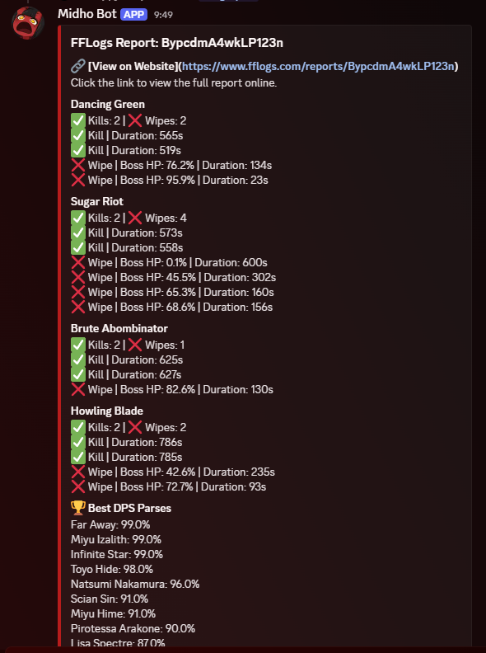
/fflogs Name Surname@Server
Output Example:
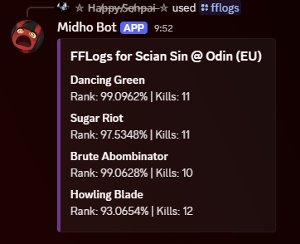

Common Issues & Fixes
Problem | Fix
NoneType errors from invalid URLs | Validate and extract report ID via regex
405 or text/html response | Ensure OAuth token from fflogs.com, not archon.gg
403/401 errors | Ensure headers contain correct Authorization: Bearer ...
Missing data fields | Guard with .get() and fallback values like "N/A"

Status Summary
Feature | Status
GraphQL v2 support | ✅
Character-based lookup | ✅
Report link analysis | ✅
Kill/wipe + best parse parsing | ✅
OAuth2 token retrieval | ✅
Embed formatting and sorting | ✅

Future Enhancements
- Show All Star %, Best Hist % if present
- Include player/job filter (specific parse for a character)
- Auto-delete commands for privacy/security
- Detect invalid or expired reports
- Add role-based summary filters (DPS only, tanks, etc.)

Slash Command Summary
Command | Arguments | Purpose
/fflogs | character, region | Parse summary for a named character
/logreport | link | Summary of all encounters in a log URL

